Direct Behavior Rating of Working with Peers – Student Name: Frankie

Directions: When working with a partner/group, Frankie will move FROM demonstrating the following skills with 40% accuracy: 1. Accepted who I worked with, 2. Shared ideas (agrees/disagrees respectfully), 3. used a calm and quiet voice TO demonstrating 80% accuracy of stated skills as measured by a direct behavior rating scale.

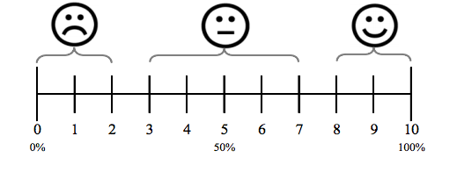
Rater: Mrs. Humphrey
Activity: Working with Peers

Monday Date:

Notes:

Tuesday Date:

Notes:

Wednesday Date:

Notes:

Thursday Date:

Notes:

Friday Date:

Notes:

